CONTINUOUS ASSESSMENT TEST - I
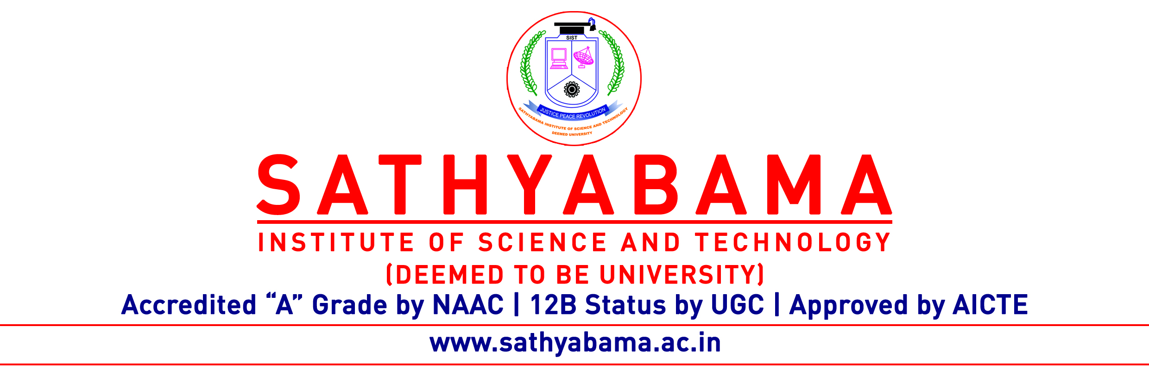
Program : CSE Max. Marks : 30
Course : B.E Time : 1 Hour
Course Code : SCS1301 Sem : V
Batch : 2018-2022 Date : 21.9.2020
Part-A Answer ALL the questions (5×2=10)

Q.No | Questions | CO (L)
 | What are the main functions of operating system? | CO1(L1)
 | List the six layers in Layered approach of OS | CO1(L1)
 | Summarize the types of thread | CO1(L2)
 | Illustrate the queues used in Process Scheduling | CO2(L2)
 | Compare Medium Term and Long Term Scheduler(Any two points) | CO2(L2)
Part-B Answer ALL the questions (2×10=20)

Q.No | Questions | CO (L)
 | What are the services of the operating System | CO1(L1)
 | (OR)
 | Explain the types of system calls in detail | CO1(L2)

 | Find the Average Waiting time and average Turnaround time for the below processes | CO2(L1)
  Process | Burst Time
  P1 | 7
  P2 | 9
  P3 | 2
  P4 | 5
 | (OR)
 | Outline the Process and its life cycle with neat sketch | CO2(L1)

